Guitar Hero (2005, PS2), Harmonix. GAMEPLAY MODE

1. Composition
Tangible space | The projected fretboard is where player agency is deployed. The background changes according to character.
Intangible space | Meters for score and audience reaction are styled after music gear.  Characters and setting in backdrop ignore player action and are intangible.
Negative Space | None; the whole screen is used.
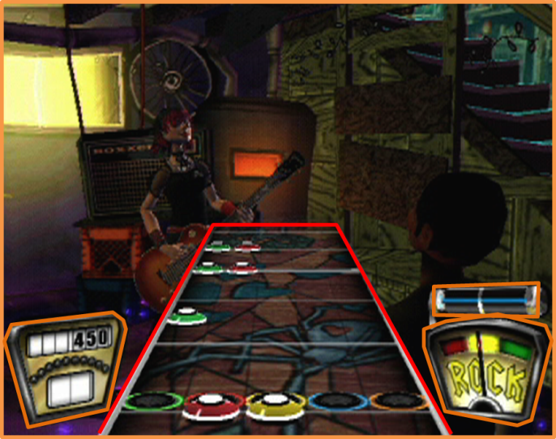
External | Player Intangible and tangible
2. Ocularization

3. Framing mechanisms | Anchor : Anchorless | Mobility : Fixed

4. Plane Analysis
 | Agents | In-game | Off-game
Graphical materials | Real-time polygons | Raster graphics (texture) | Real-time polygons
Projection method | Linear projection | Linear projection | Linear projection
Angle of projection | Overview | Overview | Various

Notes :
A case of interface-driven game. The characters and settings are decorative and make up the off-game environment. Gameplay occurs on the projected band that imitates a guitar fretboard. This fretboard varies for each player-character, making the in-game environment something of a constant visual signature.

The in-game environment and agents remain constant in intangible ocularization to favor gameplay, while the background graphics in the off-game plane constantly shift framings with tangible ocularization and framing mechanisms mimicking a “live music show” camera montage. This creates a dynamic spectacle that brings balance to the overall composition.

